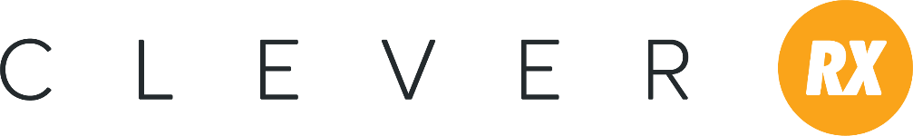
Prospecting Email Language for Providers
Hello, (Client Name),
As a trusted agent in your community, I believe it is my duty to inform you of new and important updates in the health insurance industry. For that reason, I am excited to tell you about Clever RX. Clever RX is a prescription savings card that can save your patients up to 80% at the pharmacy. It’s free to use and is accepted at most pharmacies nationwide. Best of all, you can choose for a portion of proceeds to go to the charity of your choice every time a patient saves with Clever RX. Click here for more information (link to provider flyer).
Want to know how you can get Clever? Call me today to learn more!
(Agent Signature)

Getting Started Email Language for Providers
Hello, (Name),
Thank you for your interest in Clever RX! To help your patients take advantage of this prescription savings program, they can simply download the Clever RX app from the App Store or Google Play for Androids. Then, type in these codes to start saving today:
- Group number (number here)
- Member number (number here)
(Optional) To make it even easier, I’ve attached a buckslip or statement stuffer for you to leave for patients in your office. This simple piece walks them through the steps needed to get started with Clever RX. If you’d like these printed, please let me know.
If you have any questions about Clever RX, call or email me at your earliest convenience. I’m happy to help.
Thank you for time and have a great day!
(Agent Signature)

