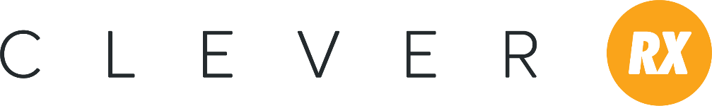
Prospecting Email Language for Individuals
Hello, (Name),
I am excited to tell you about a new, free program called that could save you significant dollars when you purchase prescription drugs. Clever RX is a prescription savings card that can save you and your family up to 80% at the pharmacy. Best of all, it’s free for you to use and is accepted at most pharmacies nationwide! Click here to learn more (link to consumer flyer).
Want to know how you can get Clever? Call me today!
(Agent Signature)

Getting Started Email Language for Individuals
Hello, (Name),
Thank you for your interest in Clever RX! To take advantage of this prescription savings program, simply download the Clever RX app from the App Store for iPhones or Google Play for Androids. Then, type in these codes to start saving today:
- Group number (number here)
- Member number (number here)
Need help using the app? Click here to access an easy to use guide (link to app guide).
Have questions about Clever RX? Call or email me at your earliest convenience. I’m happy to help.
Thank you for time and have a great day!
(Agent Signature)

